ภาคผนวก จ
การติดตั้งคอมโพเนนต์บน

Microsoft Transaction Server

ขั้นตอนการติดการติดตั้งคอมโพเนนต์บน Microsoft Transaction Server
ขั้นตอนที่ 1 เขียน COM component ที่ทำงานฝั่ง server โดยเลือกสร้างโปรเจกต์ชนิด ActiveX dll
ขั้นตอนที่ 2 นำเอา COM component ไป install ลงใน Microsoft Transaction Server (MTS)
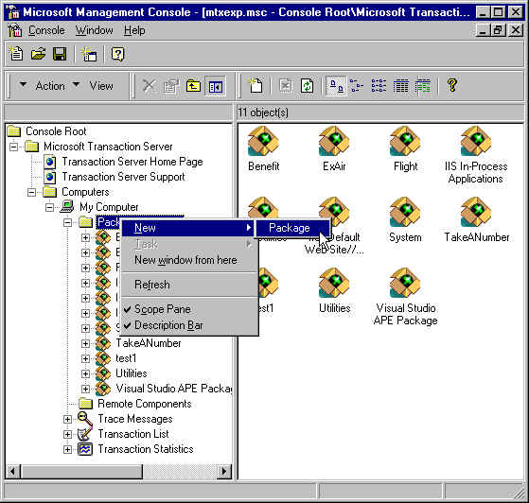
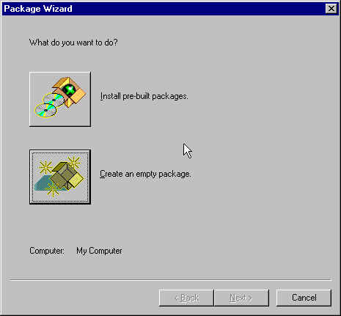
2.1 สร้างแพคเกจว่าง โดยเลือก create an empty package ดังรูป ข-1
รูปที่ จ-1 แสดงการเลือกสร้างแพคเกจใหม่

  - กำหนดชื่อแพคเกจที่ต้องการสร้าง
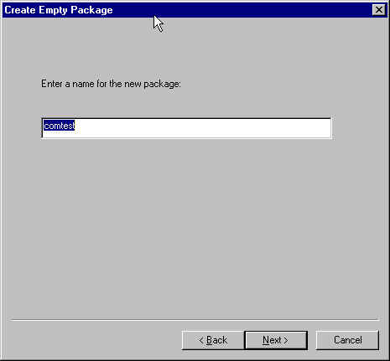
รูปที่ จ-2 แสดงการกำหนดชื่อแพคเกจ

  - กำหนด account ของการเรียกใช้ดอมโพเนนต์ ในตัวอย่างนี้เลือก แบบ interactive user
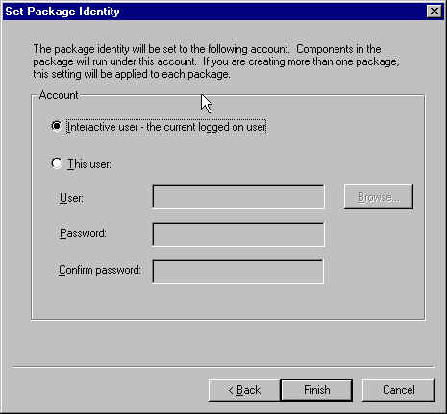
รูปที่ จ-3 แสดงการกำหนด account

  - หลังจากสร้าง package แล้วจะต้องเพิ่มคอมโพเนนท์ลงไปในแพคเกจ โดยเลือก install new component ดังรูป ข-4
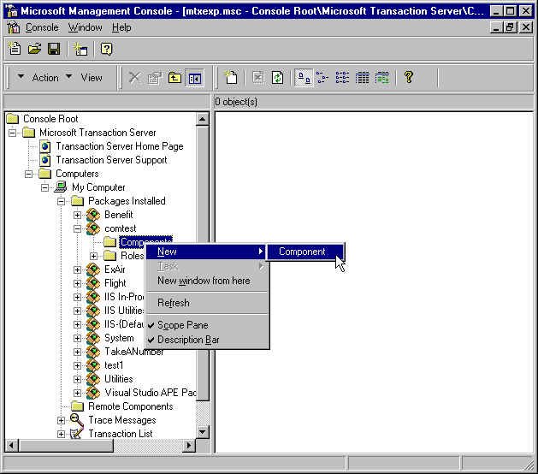
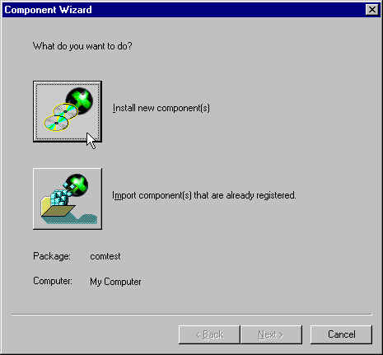
รูปที่ จ-4 แสดงการเพิ่มคอมโพเนนท์ลงไปในแพคเกจ

  - กำหนด path ของไฟล์ .dll

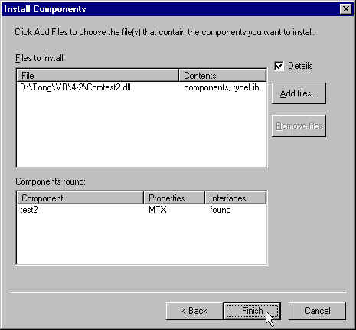
รูป จ-5 แสดงการกำหนด Path ของคอมโพเนนต์ที่เป็นไฟล์ .dll

  - จากนั้นจะต้องสร้างไฟล์ติดตั้งเพื่อนำไปติดตั้งที่ฝั่งไคลเอนต์โดยกดคลิกขวาที่ชื่อ ของแพคเกจ แล้วกด export จะปรากฎดังรูป แล้วเลือก path ที่ต้องการสร้างไฟล์ติดตั้ง
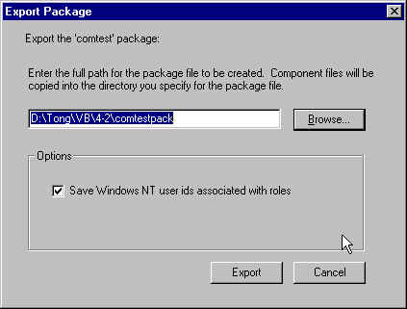
รูปที่ จ-6 แสดงการเลือก Path ที่ต้องการสร้างไฟล์ติดตั้ง

ขั้นตอนที่ 3 การเขียนฟอร์มฝั่งไคลเอนต์โดยจะต้องอ้างอิงคอมโพเนนท์ที่สร้างไว้ฝั่งเซิฟเวอร์
ขั้นตอนที่ 4 นำไฟล์ติดตั้งที่ได้จากการ export และ ไฟล์แอปพลิเคชั่น .exe ที่คอมไพล
จาก ฟอร์มฝั่งไคลเอนต์ ไปรันโดยจะต้องรันไฟล์ติดตั้งก่อนเพื่อบอกให้ไคล์เอนต์รู้ว่าเซิฟเวอร์อยู่ที่ใด

รายละเอียดลักษณะของ MTS

Microsoft Transaction Server—Complete Features at a Glance
Feature | Description and Benefits
Ease-of-Use
Simplified Three-Tiered  Application Development | MTS completely separates three-tiered infrastructure from presentation and application logic. This lets MTS developers build their applications as a collection of single-user COM components and then deploy components in the appropriate tier. Components that run on middle-tiered servers automatically support multi-user operation.
COM Component Support | MTS supports any tool that can produce COM DLLs, including Microsoft Visual Basic, Microsoft Visual C++® development system, and Microsoft Visual J++.
Simple Application Programming Interfaces | MTS developers have to learn only a simple set of APIs to deploy their components in the MTS run-time environment. Extensive knowledge of COM APIs and Win32 APIs is not required.
Support for Component  Packages | MTS lets developers combine related components into packages. Packages provide an easy way to secure, manage, and deploy components as a group.
MTS Explorer | The MTS Explorer is a GUI-based systems management console that makes it easy for administrators to create and manage packages, configure component properties such as security and transaction behavior, and monitor/manage operating servers. The MTS Explorer supports advanced ease-of-use features such as drag-and-drop editing and multiple item selection.
Microsoft Management Console Support | The MTS Explorer management interface can run as a snap-in to the Microsoft Management Console (MMC). MMC integration provides users with a consolidated management environment with a consistent look and feel.
Automatic Client Installation Utility | MTS provides a utility that simplifies and automates the process of configuring client machines that need to access MTS-based components running on a server.
Comprehensive Functionality
Automatic Transaction  Management | MTS provides automatic transaction management services to components. Developers or administrators use simple property page interfaces to specify what level of transaction protection is required by a given component. At run time, MTS performs all required transaction management automatically. This dramatically simplifies development and facilitates component reuse.
Database Connection  Pooling | MTS allocates connections to database resources from a pool. Components only require connections when they are active. This lowers the total number of database connections required to support clients, increasing database performance.

Microsoft Transaction Server—Complete Features at a Glance
Feature | Description and Benefits
Comprehensive Functionality (Cont.)
Transactional ODBC Driver for Oracle and DB2 Databases | MTS includes an ODBC 3.0-compliant driver for Oracle version 7.3 and later and DB2. ODBC 3.0 compliance lets developers build MTS applications that access these databases (on any platform), along with access to other resources such as SQL Server and Microsoft Message Queue Server, in transactional units of work for full data integrity protection. ODBC 3.0 compliance also lets MTS perform connection pooling of Oracle and DB2 database sessions for improved performance.
Support for Multiple  Databases and Resource Managers | Components running under MTS can access multiple databases and other resources such as message queuing systems and mainframe applications, simultaneously and with full data integrity protections. MTS automatically manages transactions so that all databases and other resources included in a request commit or abort as a unit.
No MTS Client Footprint | MTS applications require no libraries or run-time environment on client machines beyond that provided by COM and Distributed COM (DCOM).
Windows NT Workstation and Windows 95/98 Support | MTS supports operation on Windows NT Workstation and Windows 95/98 so that companies can deploy stand-alone versions of their MTS applications.
Process Isolation | MTS Administrators can configure packages to run in their own process to ensure that failures do not spread to other packages.
Automatic Thread Pooling | As requests come from clients, MTS automatically assigns threads to components from a pre-allocated pool. When a component finishes executing, MTS reclaims the thread. This reduces the overhead of thread creation/deletion for better performance.
Automatic Object Instance Management | MTS creates instances of components on the server only when requested and reclaims memory resources when the component finishes executing. This form of just-in-time (JIT) activation and as-soon-as-possible deactivation minimizes memory requirements on server machines.
Shared Property Manager | MTS provides the Shared Property Manager to simplify programming of components that need to save state information or share state with other components.
Integration with Windows NT Features and Microsoft Products
Integration with Microsoft  SQL Server 6.5 | Microsoft SQL Server 6.5 provides an OBDC 3.0 driver that provides extremely fast and efficient transactional integration, based on Microsoft Distributed Transaction Coordinator (DTC) to MTS applications. Because MTS also uses DTC for transaction management, administrators can use the same utilities to manage transactions between MTS and SQL Server, simplifying systems administration

Microsoft Transaction Server—Complete Features at a Glance
Feature | Description and Benefits
Integration with Windows NT Features and Microsoft Products (Cont.)
IIS Integration | Microsoft Internet Information Server version.4.0 is integrated with MTS and uses MTS for many run-time services such as transaction management. MTS integration makes it easy for IIS Active Server Pages to call MTS components that access databases, mainframe applications, and message queues with full data integrity protection. MTS integration also provides IIS with process isolation to prevent individual failures from affecting other parts of a Web site, enhanced run-time services such as thread and connection pooling for better performance, and easier component management.
MSMQ Integration | MTS provides integration with Microsoft Message Queue Server (MSMQ). MSMQ integration lets MTS-based applications communicate in a reliable, loosely coupled fashion. MSMQ operations (such as send and receive) enlist in MTS transactions automatically for data integrity protection
SNA Server 4.0 Integration | MTS can use Microsoft SNA Server 4.0 and the COM Transaction Integrator to include mainframe applications (e.g., running under CICS and IMS) and their data in transactions managed by MTS. MTS-based applications can update one or more databases, send or receive messages with MSMQ, and invoke a mainframe application that updates data (e.g., in VSAM), and all updates, including those on the mainframe, will commit or abort as a whole. Microsoft SNA Server 4.0 also makes it easy to generate COM-based interfaces to mainframe applications for simplified MTS programming.
Support for Windows NT Clustering Services | MTS supports operation on clustered Windows NT Servers. Clustering enables administrators to configure MTS packages for automatic failover and fault-tolerant, high-availability operation.
Windows NT Security  Integration | MTS provides a role-based security mechanism that is integrated with the Windows NT security environment. Roles let developers design security protections into their components without knowing how the components will be ultimately deployed. Administrators map roles to users when they install components into MTS.

